STAC32 Assignment 2

1. (a)
> baseball=read.table("runs.txt",header=T)
> runs
Team Runs League
1 Rockies 10.4 National
2 Phillies 10.3 National
3 Cincinnati 10.0 National
4 Diamondbacks 10.0 National
5 Braves 9.7 National
6 Dodgers 9.7 National
7 Cubs 9.6 National
8 Giants 9.5 National
9 Nationals 9.5 National
10 Brewers 9.4 National
11 Pirates 9.1 National
12 Marlins 9.0 National
13 Cardinals 9.0 National
14 Astros 8.9 National
15 Mets 8.9 National
16 Padres 7.9 National
17 Royals 11.4 American
18 WhiteSox 10.6 American
19 Rangers 10.4 American
20 RedSox 10.3 American
21 Orioles 10.2 American
22 BlueJays 10.0 American
23 Yankees 9.9 American
24 Indians 9.9 American
25 DevilRays 9.7 American
26 Tigers 9.1 American
27 Twins 9.0 American
28 Mariners 9.0 American
29 Athletics 8.9 American
30 Angels 8.8 American

We have the three columns as above: Team, Runs, and League.

(b)

boxplot(Runs~League, data=runs)

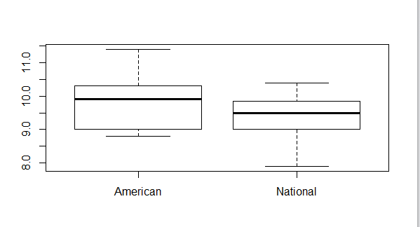
The median of the American team is higher.

(c)
t.test(Runs~League,data=runs,alternative="greater")
Welch Two Sample t-test

data: Runs by League
t = 1.4298, df = 25.231, p-value = 0.08252
alternative hypothesis: true difference in means is greater than 0
95 percent confidence interval:
-0.0716207 Inf
sample estimates:
mean in group American mean in group National
9.80000 9.43125

The P-value is greater than 0.05 therefore the null hypothesis is true; hence their mean value is close.
- （a）
data runs;
infile '/home/victor.xu/runs.txt' firstobs=2;
input team $ runs league $;
proc print;
Obs | team | runs | league
1 | Rockies | 10.4 | National
2 | Phillies | 10.3 | National
3 | Cincinna | 10.0 | National
4 | Diamondb | 10.0 | National
5 | Braves | 9.7 | National
6 | Dodgers | 9.7 | National
7 | Cubs | 9.6 | National
8 | Giants | 9.5 | National
9 | National | 9.5 | National
10 | Brewers | 9.4 | National
11 | Pirates | 9.1 | National
12 | Marlins | 9.0 | National
13 | Cardinal | 9.0 | National
14 | Astros | 8.9 | National
15 | Mets | 8.9 | National
16 | Padres | 7.9 | National
17 | Royals | 11.4 | American
18 | WhiteSox | 10.6 | American
19 | Rangers | 10.4 | American
20 | RedSox | 10.3 | American
21 | Orioles | 10.2 | American
22 | BlueJays | 10.0 | American
23 | Yankees | 9.9 | American
24 | Indians | 9.9 | American
25 | DevilRay | 9.7 | American
26 | Tigers | 9.1 | American
27 | Twins | 9.0 | American
28 | Mariners | 9.0 | American
29 | Athletic | 8.9 | American
30 | Angels | 8.8 | American

(b)
proc boxplot;
plot runs*league / boxtype=schematic;
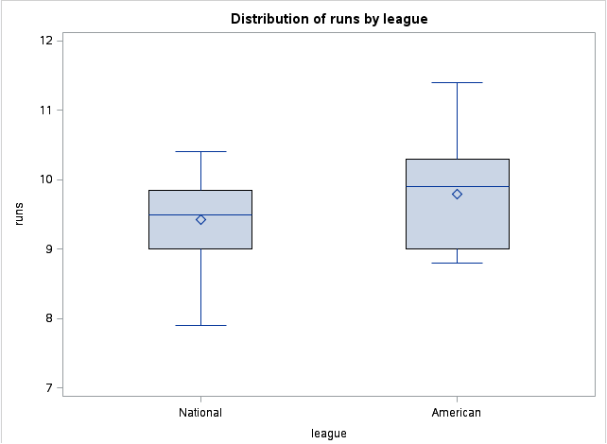
The mean and median of the American league are higher than those of National’s.

(c)
proc ttest side=u;
var runs;
class league;
The TTEST Procedure
Variable: runs
league | N | Mean | Std Dev | Std Err | Minimum | Maximum
American | 14 | 9.8000 | 0.7656 | 0.2046 | 8.8000 | 11.4000
National | 16 | 9.4313 | 0.6279 | 0.1570 | 7.9000 | 10.4000
Diff (1-2) |  | 0.3688 | 0.6952 | 0.2544

league | Method | Mean | 95% CL Mean |  | Std Dev | 95% CL Std Dev
American |  | 9.8000 | 9.3580 | 10.2420 | 0.7656 | 0.5550 | 1.2334
National |  | 9.4313 | 9.0967 | 9.7658 | 0.6279 | 0.4639 | 0.9718
Diff (1-2) | Pooled | 0.3688 | -0.0641 | Infty | 0.6952 | 0.5517 | 0.9403
Diff (1-2) | Satterthwaite | 0.3688 | -0.0716 | Infty

Method | Variances | DF | t Value | Pr > t
Pooled | Equal | 28 | 1.45 | 0.0792
Satterthwaite | Unequal | 25.231 | 1.43 | 0.0825

Equality of Variances
Method | Num DF | Den DF | F Value | Pr > F
Folded F | 13 | 15 | 1.49 | 0.4589

The R did Satterthwaite because the P-values are the same: 0.0825.

- (a)
> dorito=read.table("dorito.txt",header=T)
> dorito
Weights
1 29.2
2 28.5
3 28.7
4 28.9
5 29.1
6 29.5

Same as the txt file.

(b)
> t.test(dorito$Weight,mu=29.2)
One Sample t-test

data: dorito$Weight
t = -1.4739, df = 5, p-value = 0.2005
alternative hypothesis: true mean is not equal to 29.2
95 percent confidence interval:
28.60544 29.36123
sample estimates:
mean of x
28.98333

The p-value is greater than 0.05, therefore the null hypothesis is true; that is, the data are consistent with this.
The interval level is from 28.60544 to 29.36123, which includes 29.2.
Therefore the conclusions are consistent with each other.

(c)
Yes, 29.2 should be inside the 80% interval because not only is the p-value greater than 0.05, but it is also greater than 0.2.
> t.test(dorito$Weight,mu=29.2,conf.level=0.8)
One Sample t-test

data: dorito$Weight
t = -1.4739, df = 5, p-value = 0.2005
alternative hypothesis: true mean is not equal to 29.2
80 percent confidence interval:
28.76637 29.20030
sample estimates:
mean of x
28.98333

Therefore 29.2 is inside the 80% interval.

- (a)
data doritos;
infile '/home/victor.xu/doritos.txt' firstobs=2;
input weight;
proc print;
Obs | weight
1 | 29.2
2 | 28.5
3 | 28.7
4 | 28.9
5 | 29.1
6 | 29.5

Same as original data.

(b)
proc ttest h0=29.2;
var weight;
The TTEST Procedure
Variable: weight
N | Mean | Std Dev | Std Err | Minimum | Maximum
6 | 28.9833 | 0.3601 | 0.1470 | 28.5000 | 29.5000

Mean | 95% CL Mean |  | Std Dev | 95% CL Std Dev
28.9833 | 28.6054 | 29.3612 | 0.3601 | 0.2248 | 0.8832

DF | t Value | Pr > |t|
5 | -1.47 | 0.2005

95% Confidence interval: 28.61-29.36

(c)
proc ttest h0=29.2 alpha=0.20;
var weight;
The TTEST Procedure
Variable: weight
N | Mean | Std Dev | Std Err | Minimum | Maximum
6 | 28.9833 | 0.3601 | 0.1470 | 28.5000 | 29.5000

Mean | 80% CL Mean |  | Std Dev | 80% CL Std Dev
28.9833 | 28.7664 | 29.2003 | 0.3601 | 0.2649 | 0.6345

DF | t Value | Pr > |t|
5 | -1.47 | 0.2005

80% confidence interval: 28.77-29.20

5.(a)
> power.t.test(n=20, delta=130-125, sd=10, type="one.sample",alternative="two.sided")
One-sample t test power calculation

n = 20
delta = 5
sd = 10
sig.level = 0.05
power = 0.5644829
alternative = two.sided

Therefore power is 0.56。

(b)
> power.t.test(power=0.75,delta=130-125,sd=10,type="one.sample",alternative="two.sided")
One-sample t test power calculation

n = 29.73565
delta = 5
sd = 10
sig.level = 0.05
power = 0.75
alternative = two.sided

Therefore sample size is 30.

(c)
Yes the results make sense; the original power is greater than 0.5, therefore we need a larger n to make the power bigger.

(d)
proc power;
onesamplemeans
test=t
sides=2
mean=5
stddev=10
ntotal=20
power=.;
run;
The POWER Procedure
One-Sample t Test for Mean
Fixed Scenario Elements
Distribution | Normal
Method | Exact
Number of Sides | 2
Mean | 5
Standard Deviation | 10
Total Sample Size | 20
Null Mean | 0
Alpha | 0.05

Computed Power
Power
0.565

CODE:
>proc power;
> onesamplemeans
> test=t
> sides=2
> mean=5
> stddev=10
> ntotal=.
> power=0.75;
>

>run;
RESULTS:
The POWER Procedure
One-Sample t Test for Mean
Fixed Scenario Elements
Distribution | Normal
Method | Exact
Number of Sides | 2
Mean | 5
Standard Deviation | 10
Nominal Power | 0.75
Null Mean | 0
Alpha | 0.05

Computed N Total
Actual Power | N Total
0.754 | 30

The answers are consistent; they are the same as in R.

6.(a)
> install.packages("BSDA")
> library(BSDA)

载入需要的程辑包：e1071载入需要的程辑包：lattice
载入程辑包：‘BSDA’
The following object is masked from ‘package:datasets’:

Orange

I have no idea why this is in Chinese..

> head(Tablrock)
hour X03 tmp vdc wd ws amb dew so2 no no2 nox co co2 gas air
1 01:00 22 23.1 1.47 203 0.2 17.9 15.8 0.0 0.0 0.4 0.4 0.6 0.6 -1.5 -0.06
2 02:00 21 23.2 1.47 22 0.4 17.4 15.4 0.0 0.0 0.2 0.2 0.6 0.6 -1.5 -0.06
3 03:00 17 23.4 1.47 90 0.1 17.0 14.9 -0.1 0.1 0.1 0.2 0.6 0.6 -1.5 -0.06
4 04:00 13 23.6 1.47 50 1.3 16.2 14.4 -0.1 0.0 -0.1 -0.1 0.6 0.6 -1.5 -0.06
5 05:00 12 23.7 1.47 39 2.5 15.6 14.3 -0.1 0.1 -0.1 0.0 0.6 0.6 -1.5 -0.06
6 06:00 17 23.9 1.47 0 0.0 16.1 14.1 -0.1 0.1 0.0 0.1 0.6 0.6 -1.5 -0.06

6 rows and 16 columns as required.

(b)
> attach(Tablrock)
The following object is masked from package:datasets:

co2
> hist(dew)
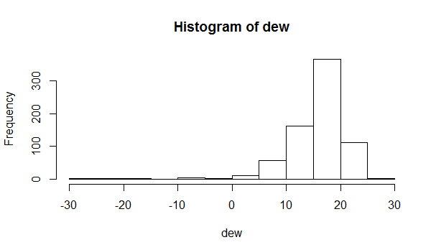
The Histogram is left-skewed; there are some extreme outliers on the left side.

(c)
Because of these extreme outliers, we should use median to compare data; sigh test is the test for median therefore the sign test will be more appropriate here.

(d)

> SIGN.test(dew,md=16)
One-sample Sign-Test

data: dew
s = 440, p-value = 9.494e-10
alternative hypothesis: true median is not equal to 16
95 percent confidence interval:
17.4 18.0
sample estimates:
median of x
17.7

Conf.Level L.E.pt U.E.pt
Lower Achieved CI 0.9476 17.4 18
Interpolated CI 0.9500 17.4 18
Upper Achieved CI 0.9561 17.4 18

The p-value is small, therefore we reject the null hypothesis; hence median is not equal to 16.

(e)
> t.test(dew,mu=16)
One Sample t-test

data: dew
t = 0.0515, df = 718, p-value = 0.9589
alternative hypothesis: true mean is not equal to 16
95 percent confidence interval:
15.59749 16.42420
sample estimates:
mean of x
16.01085

The p-value is large, therefore the null hypothesis is true; hence mean is equal to 16.

(f)
The confidence interval of sign test is from 17.4 to 18.0 while the confidence interval of t-test is from 15.6 to 16.4; therefore they are noticeably different because of the outliers.

- (a)
data tablrock;
infile '/home/victor.xu/tablrock.txt' firstobs=2;
input hour X03 tmp vdc wd ws amb dew so2 no no2 nox co co2 gas air;
proc univariate noprint;
var dew;
histogram;
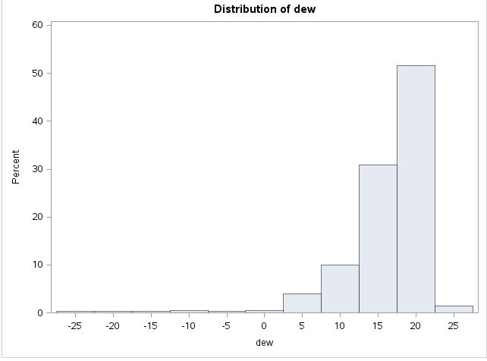
It looks the same as R.

(b)
proc univariate mu0=16;
var dew;
Moments
N | 359 | Sum Weights | 359
Mean | 16.0175487 | Sum Observations | 5750.3
Std Deviation | 5.86933596 | Variance | 34.4491046
Skewness | -3.0746652 | Kurtosis | 15.3289842
Uncorrected SS | 104438.49 | Corrected SS | 12332.7794
Coeff Variation | 36.6431596 | Std Error Mean | 0.3097717

Basic Statistical Measures
Location |  | Variability
Mean | 16.01755 | Std Deviation | 5.86934
Median | 17.70000 | Variance | 34.44910
Mode | 19.70000 | Range | 53.20000
 |  | Interquartile Range | 5.50000

Tests for Location: Mu0=16
Test | Statistic |  | p Value
Student's t | t | 0.056651 | Pr > |t| | 0.9549
Sign | M | 42.5 | Pr >= |M| | <.0001
Signed Rank | S | 7115.5 | Pr >= |S| | 0.0003

Quantiles (Definition 5)
Level | Quantile
100% Max | 26.0
99% | 23.6
95% | 21.3
90% | 20.7
75% Q3 | 19.6
50% Median | 17.7
25% Q1 | 14.1
10% | 9.2
5% | 6.7
1% | -9.5
0% Min | -27.2

Extreme Observations
Lowest |  | Highest
Value | Obs | Value | Obs
-27.2 | 265 | 23.0 | 197
-20.3 | 266 | 23.6 | 209
-15.4 | 267 | 24.4 | 80
-9.5 | 76 | 25.3 | 101
-8.4 | 77 | 26.0 | 79
- Yes it is the same as R.
- (a)
> skull=read.table("skull.txt",header=T)
> skull
X2000BCE X4000BCE
1 141 131
2 141 125
3 135 131
4 133 119
5 131 136
6 140 138
7 139 139
8 140 125
9 138 131
10 132 134
11 134 129
12 135 134
13 133 126
14 136 132
15 134 141
16 131 131
17 129 135
18 136 132
19 131 139
20 139 132
21 144 126
22 141 135
23 130 134
24 133 128
25 138 130
26 131 138
27 136 128
28 132 127
29 135 131
30 141 124

Same as original data.

(b)
> skull1=stack(skull)
> skull1
values ind
1 141 X2000BCE
2 141 X2000BCE
3 135 X2000BCE
4 133 X2000BCE
5 131 X2000BCE
6 140 X2000BCE
7 139 X2000BCE
8 140 X2000BCE
9 138 X2000BCE
10 132 X2000BCE
11 134 X2000BCE
12 135 X2000BCE
13 133 X2000BCE
14 136 X2000BCE
15 134 X2000BCE
16 131 X2000BCE
17 129 X2000BCE
18 136 X2000BCE
19 131 X2000BCE
20 139 X2000BCE
21 144 X2000BCE
22 141 X2000BCE
23 130 X2000BCE
24 133 X2000BCE
25 138 X2000BCE
26 131 X2000BCE
27 136 X2000BCE
28 132 X2000BCE
29 135 X2000BCE
30 141 X2000BCE
31 131 X4000BCE
32 125 X4000BCE
33 131 X4000BCE
34 119 X4000BCE
35 136 X4000BCE
36 138 X4000BCE
37 139 X4000BCE
38 125 X4000BCE
39 131 X4000BCE
40 134 X4000BCE
41 129 X4000BCE
42 134 X4000BCE
43 126 X4000BCE
44 132 X4000BCE
45 141 X4000BCE
46 131 X4000BCE
47 135 X4000BCE
48 132 X4000BCE
49 139 X4000BCE
50 132 X4000BCE
51 126 X4000BCE
52 135 X4000BCE
53 134 X4000BCE
54 128 X4000BCE
55 130 X4000BCE
56 138 X4000BCE
57 128 X4000BCE
58 127 X4000BCE
59 131 X4000BCE
60 124 X4000BCE

We have indeed one column of skulls and one column of time as needed.

(c)
> boxplot(values~ind,data=skull1)
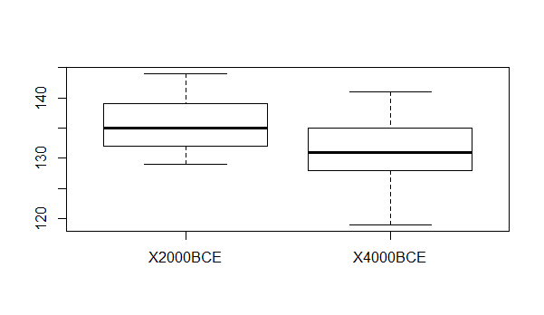
The boxplot for X2000BCE is a bit left skewed while the boxplot for X4000BCE is a bit right skewed; however there is no outlier for each boxplot;
Therefore a t-test should be suitable.

(d)
> mean=aggregate(values~ind,data=skull1,mean)
> mean
ind values
1 X2000BCE 135.6333
2 X4000BCE 131.3667

(e)
> mean[1,2]-mean[2,2]
[1] 4.266667

(f)
(i)
> attach(skull1)
> shuffle=sample(ind,length(ind))
> shuffle
[1] X4000BCE X4000BCE X2000BCE X2000BCE X4000BCE X4000BCE X4000BCE X4000BCE X2000BCE
[10] X4000BCE X4000BCE X2000BCE X4000BCE X2000BCE X2000BCE X4000BCE X4000BCE X2000BCE
[19] X2000BCE X2000BCE X2000BCE X4000BCE X4000BCE X2000BCE X4000BCE X4000BCE X2000BCE
[28] X4000BCE X2000BCE X2000BCE X2000BCE X4000BCE X4000BCE X4000BCE X2000BCE X2000BCE
[37] X2000BCE X2000BCE X2000BCE X2000BCE X2000BCE X2000BCE X4000BCE X4000BCE X2000BCE
[46] X4000BCE X4000BCE X4000BCE X4000BCE X4000BCE X2000BCE X2000BCE X2000BCE X4000BCE
[55] X4000BCE X4000BCE X2000BCE X4000BCE X2000BCE X2000BCE
Levels: X2000BCE X4000BCE

(ii)
> mean1=aggregate(values~shuffle,data=skull1,mean)
> mean1
shuffle values
1 X2000BCE 133.6
2 X4000BCE 133.4

(iii)
> mean1[1,2]-mean1[2,2]
[1] 0.2

The mean difference is 0.2, which is much smaller than the data in (d).

(g)
> nsim=10000
> ans=numeric(nsim)
> for (i in 1:10000)
+ {
+ shuffle=sample(ind,length(ind))
+ mean1=aggregate(values~shuffle,data=skull1,mean)
+ ans[i]=mean1[1,2]-mean1[2,2]
+ }
> hist(ans)
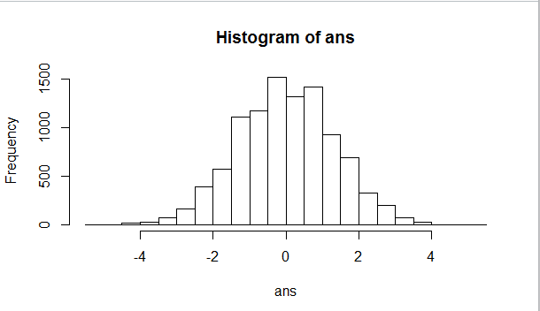

(h) The observed value from (e) is 4.27, which is still possible in the graph, however with little chance therefore unlikely.
(i)
> table(ans>=4.2667)
FALSE TRUE
9997 3

P value is 3/10000=0.0003. Therefore we reject the null hypothesis and thus conclude difference between skull breaths is significant.

